City and County of San Francisco
London N. Breed
Mayor
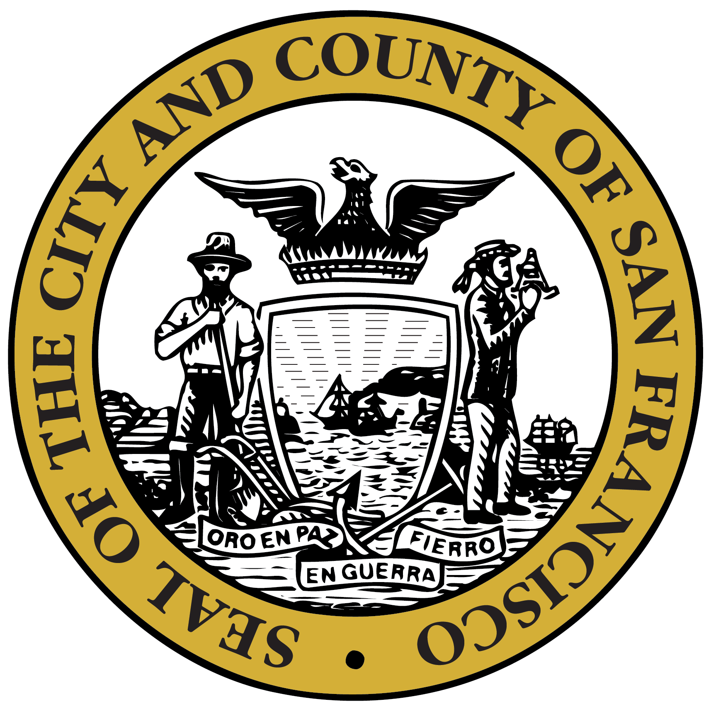
San Francisco Department of Public Health
Grant Colfax, MD
Director of Health

Letters of Support for Grants
Funders may require support letters to accompany grant applications. These letters are in support for DPH grant applications and for those agencies funded by DPH. In all cases, Letters of Support requested for signature by our Acting Director, Greg Wagner, MUST first be emailed to the Office of the Director of Health for review. This allows the Director’s Office to track all requests and to avoid duplicate letters.

Please Note: All Letters of Support MUST go through the Office of the Director of Health. Therefore, the Director of Health is the ONLY authorized signatory to sign on behalf of the Department of Public Health.

Letter of Support Guidelines
- To obtain a Letter of Support from the Director of Health, please prepare to submit (email) the following items to the Director’s Office at least TWO weeks in advance of the requested due date:
- Letter of Support Request Form (See Page 3)
- DRAFT Letter of Support
  - Letters of Support must include the formal address of the addressee.
“To Whom It May Concern” will not be accepted.
  - The Director of Health will NOT sign Letters of Commitment, only support letters.

The Office of the Director of Health receives a large number of requests for signatures that need to go through the appropriate review process. Therefore, "Letters of Support” requests are required to be submitted TWO weeks in advance of the requested due date. We understand that there will be last minute requests for Letters of Support and will do our best to accommodate accordingly. However, failure to provide a two-week notice may result in not receiving a signed Letter of Support.

Letter of Support Process
The following details each step in the Letter of Support process:
- Fill out the Letter of Support Request Form and email to the Director’s Office WITH the draft letter.
  - Note: The Director’s Office is not responsible for drafting the letter. Please do not request that we include additional information in the letter. We request the letter be finalized when it is submitted for approval. The Director’s Office will be responsible for placing the letter on official letterhead.
- Once the draft letter AND request form have been received, the Director’s Office will review the letter and contact you if there are questions and/or issues.
- After the Director’s Office has reviewed, approved, and signed the letter, the Director’s Office will EMAIL an electronic version of the letter to the designated contact person.
  - If you wish to receive the letter with an original signature, please notify the Office of the Director of Health once you receive the electronic copy.

About San Francisco Department of Public Health
(Optional language to include IF needed for Letter of Support)
The mission of the San Francisco Department of Public Health is to protect and promote the health of all San Franciscans. SFDPH is an integrated health department with two major Divisions: the San Francisco (SF) Health Network and the Population Health Division.

The San Francisco Health Network is a community of top-rated clinics, hospitals and programs operated by the Health Department. We connect San Franciscans to quality health care.
Every year we serve more than 100,000 people in our clinics and hospitals, such as Castro Mission, Chinatown, and Southeast health centers, Zuckerberg San Francisco General and Laguna Honda Hospital and Rehabilitation Center. We provide continuous care for people wherever they are –in clinics, hospitals, at home, in jail, in transitional housing or on the streets. As the city’s public health system, we also provide emergency, trauma, mental health and substance use care to any San Franciscan who needs it.

The Health Network celebrates the city’s diversity, serving individuals and families of all backgrounds and identities, regardless of immigration status or lack of insurance. The Health Network is dedicated to empowering all San Franciscans, without exception, to live the healthiest lives possible.

The Population Health Division (PHD) provides core public health services for the City and County of San Francisco: health protection, health promotion, disease and injury prevention, and disaster preparedness and response. PHD delivers the following ten essential public health services: (1) conduct and disseminate assessments focused on population health status and public health issues facing the community; (2) investigate health problems and environmental public health hazards to protect the community; (3) inform and educate about public health issues and functions; (4) engage with the community to identify and address health problems; (5) develop public health policies and plans; (6) enforce public health laws; (7) promote strategies to improve access to health care services; (8) maintain a competent public health workforce; (9) evaluate and continuously improve processes, programs, and interventions; and (10) contribute to and apply the evidence base of public health.

For further questions, please contact Michaela Varisto at (415) 554-2526 or
Michaela.varisto@sfdph.org

City and County of San Francisco
London N. Breed
Mayor
San Francisco Department of Public Health
Grant Colfax, MD
Director of Health

LETTER OF SUPPORT REQUEST FORM

MUST BE SUBMITTED TWO WEEKS IN ADVANCE OF REQUESTED DUE DATE
ALL FIELDS ON THIS FORM MUST BE COMPLETED. PLEASE ATTACH THIS FORM WITH YOUR DRAFT LETTER OF SUPPORT. BE SURE TO INCLUDE THE FORMAL ADDRESS OF THE ADDRESSEE IN YOUR LETTER. EMAIL to
Michaela.varisto@sfdph.org when completed.
GRANT INFORMATION
1. Type of Grant: |  | Federal |  | State |  | Private |  | Other

2. Name of Grant Funding Agency (ex. SAMHSA, HRSA, DOJ, etc):

3. Official Title of Grant Application on Announcement:

4. Request for Applications (RFA)/ Request for Proposals (RFP) No.:

5. Catalogue of Federal Domestic Assistance (CFDA) No.:

6. Amount of Grant Funding Applied for: $

7. Grant Project Schedule, as proposed: Start Date: ______________ End Date: ______________
8. Date Letter is Requested by: 9. Grant Application Deadline:

DEPARTMENT OF PUBLIC HEALTH AND/OR AGENCY/CITY DEPARTMENT INFORMATION
10. | Letter is Requested by:  DPH (Proceed to #11 & 12) Agency/City Department (Proceed to #13) Both (Proceed to #11, 12, 13)
11. | DPH Division (If Applicable):  Population Health Division SF Health Network
12. | DPH Section:
13. | Agency Name/City Department (If Applicable):

CONTACT INFORMATION
14. | Grant Project Manager: | 16. | Telephone:
15. | Address: | 17. | Email:

GRANT DESCRIPTION
A. Project Name
B. Abstract (5-10 Lines)
C. How Grant Supports DPH Health Goals
For further questions, please contact Michaela Varisto at (415) 554-2526 or
Michaela.Varisto@sfdph.org

