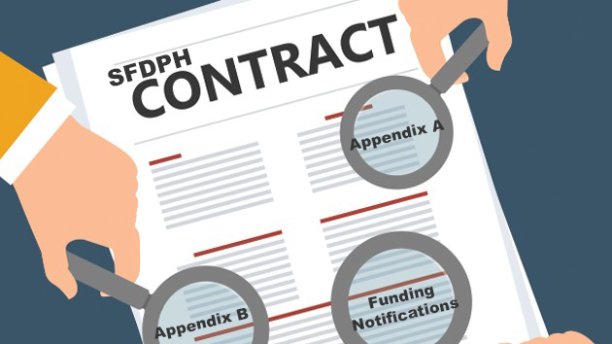
WHAT YOU NEED TO KNOW:
CONTRACTING
for
FY 20-21

Below are general answers to your frequently asked questions about how DPH will proceed with contract development and payment issues for FY 2021. These responses will apply to most contracts; some contracts will have exceptional circumstances which will be handled on a case-by-case basis.

u Contract Extensions/Funding Continuation
Similar to “normal” contracting years, if you have a multi-year contract that did not expire on 6/30/20, your contract funding will continue. The difference this year is that the City’s budget won’t be completed until October 1, so we do not yet know the changes that may impact your contract funding levels in FY20-21. To prevent a break in payment, while waiting for final budget allocations, the funding level for contract extensions will be based on FY 19-20 contract funding levels (less one-time funding). If you have a contract with BHS, this will reflect the normal payment process that occurs prior to the submission of annually updated appendices. Some variation may occur depending on contract expiration dates, funding sources and solicitation status.
If your FY 19-20 contract expired on June 30, 2020, but the services have been determined to be ongoing, an amendment will be processed to extend the contract, again based on FY19-20 funding levels. A revision to the program budget (RPB) will be processed after October 1, 2020 to reflect any changes based on the approved FY 20-21 General Fund Budget
u Initial Payments (BHS)

BHS contractors should begin to look for your Initial Payments during the month of July. As usual, initial payments will be calculated based on 25% of your eligible FY 19-20 contract funding, less one-time funding amounts. There is no expected change to the existing process, meaning no contract document submission is required, with the only requirement being to sign an invoice and to ensure that all FY20-21 updated insurance is in place.

u Funding Reductions

The Department submitted its target reduction proposal to the Mayor’s Office, following review at the Health Commission on June 16, 2020. This proposal did not contain any service reductions, instead relying on the usage of one-time savings and revenues and operational efficiencies to balance. The Mayor’s Office may initiate changes to achieve a City-wide balanced budget prior to submission to the Board of Supervisors (BOS). The BOS will deliberate on the balanced budget, oftentimes offering alternatives to proposed reductions. Other Departments have submitted their own budget proposals to the Mayor, and because DPH receives a significant level of funding from other City Department’s through work-order funding, there is a potential service level impact. At this stage, it is too early to know the full budget scenario for FY20-21. Please note, however, that we anticipate any budget reductions to be effective October 1, and not July 1. At this time, consideration of annual Cost of Doing Business increases in FY20-21 will occur by the Mayor and Board of Supervisors. If CODB funds are awarded, we do not know if the funding will be effective October 1 or July 1. The System of Care Directors will communicate any budget reductions to you, followed by written notification.

u Funding Notifications

The final City budget will be adopted October 1, 2020. Funding Notification letters will be released on or before October 1, based on whether budget changes are solidified earlier, and based on the need for a contract negotiation. Generally, a Funding Notification letter will be issued following a contract negotiation, if one is needed. For non-BHS contractors, if there is no change from the FY19-20 budget, then your existing multi-year Funding Notification is still valid. You will be notified of any budgetary changes that may occur due to City budget deliberations. If you would like to request a contract negotiation, you may submit a Contract Change Request Form (CCR) and check the box in the upper right corner, indicating that you would like to have a contract negotiation. This form is located on the CDTA website: https://www.sfdph.org/dph/files/CDTA/Contract-Change-Request-ML-Appr-7-27-18-Locked-Text.docx

u Contract Documents
Contract documents submission should follow the due date indicated on the Funding Notification letter. Unless directed otherwise, it will be unnecessary to submit any contract documents (i.e. updated exhibits) prior to the release of the Funding Notification. Invoice templates will be issued based on FY19-20 budgets. Following the new protocol begun in FY19-20, all contract documents must be submitted to the email address: cdtaunit@sfdph.org, where they will be routed to the appropriate personnel. Remember to update any continuing subcontract agreements and submit them with your Appendix A and B documents.

u Federal Paycheck Protection Program (PPP) Loan Funding

At this time, the Department is still considering a process for resolving your questions regarding carryforward of unspent funds from FY 19-20 due to the substitution of eligible expenses with payment using PPP funding. Regardless, it will be a case-by-case decision making process because per the Funding Reduction section above, instead of implementing service reductions in FY20-21, the Department is relying on the usage of one-time savings from FY19-20, along with revenues and operational efficiencies to balance. If you would like to jump start a request, you may submit a Contract Change Request form identifying the amount you would like to carry forward and the purpose. This form is located on the CDTA website: https://www.sfdph.org/dph/files/CDTA/Contract-Change-Request-ML-Appr-7-27-18-Locked-Text.docx

u Contract Monitoring

The plan for monitoring of FY19-20 programs is still under development. However, a preliminary plan is that BOCC will provide a program monitoring report that provides a record of each program’s achievements and status during FY 19-20. However, no scoring will be applied by BOCC to any results found within the normal data sources, such as electronic medical records and program Year End Reports. All categories of review will have results simply stated without measuring/scoring any comparison with contractual expectations. Except for the HHS programs funded by HRSA, each program monitoring report will be populated with available data without any site visits being made.

u Contract Restructuring for COVID-19 Response
As a financial strategy for minimizing service reductions, contractors have been and will be serving in a disaster service worker capacity into (and through?) FY20-21. While we will be doing more focused informational outreach, if you would like to learn more now, please send an email to cdtaunit@sfdph.org and we will contact you.
We are currently determining if the current format that we have been using to add a COVID scope (adding an Emergency Services Addendum) will continue in the FY20-21 contract. Alternatively, a significant reallocation may need to be reflected in a new exhibit. This will be shared as soon as we have information. However, if you have questions, or concerns regarding COVID and FY20-21 contract format, please direct those to: michelle.ruggels@sfdph.org.

