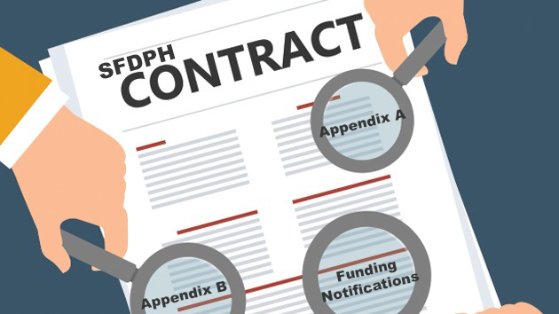
WHAT YOU NEED TO KNOW:
Updates & Delay in BHS Initial Payments for
FY 20-21 - Revised

August 10, 2020

Dear Contractor,

Please note the following updates:

1. The Continuity of Payment policy that was in effect in FY 19-20 will continue through September 30, 2020. After that, it will only be approved on a case-by-case basis at the level of the Mayor’s Office. If you plan to continue to receive payment per this policy, please submit the attached form as it will be necessary to seek approval for FY 20-21. For details on the Controller’s Office policy, please see the link below:

https://sfcontroller.org/expedited-contract-modification-policy-and-updated-continuity-payment-nonprofit-suppliers-policy

2. DPH Business Office Staff have comprised a Frequently Asked Questions (FAQ) document to clarify the use of the Invoice Variance Policy and Procedures. Please see the attached document, which will soon also be listed on the CDTA website : www.sfdph.org/cdta.

ADDITIONAL UPDATES:

Initial Payments – Behavioral Health Services (BHS) Contracts only

Due to the overwhelming extra volume of demand on our system, we are experiencing a delay in processing the FY 20-21 initial payments (IP) for some contractors. While some of you have received your IP, others of you are still waiting. Many of you are also waiting for FY20-21 invoice templates. Please know that the Contracts Analyst staff have worked over-time last weekend to put a significant dent in the volume.

Preparing and Processing Initial Payment Invoices and FY20-21 Invoices is a multi-step process:

- Step 1. The Contract Analyst sets up an encumbrance of FY20-21 funding, which is the required step to make the funding in your contract available to reimburse monthly invoices and the initial payment. This encumbrance, if updated FY20-21 appendices are pending, is based on FY19-20 funding levels. BHS often refers to this, by way of shorthand as an MYE, or Multi-Year Encumbrance. So, if you hear that terminology used, it simply means an encumbrance for FY20-21 funding, based on FY19-20 funding levels. No payments of any type can occur until this encumbrance process has been completed.

- To issue the Initial Payment, the Contract Analyst must prepare an Initial Payment Invoice, which will be: (1) sent to you for signature, and then (2) sent to DPH’s Fiscal, Accounts Payable for approval and processing in FSP (the City’s payment system). This is followed by payment.

3. After Step 1 is completed, the DPH Invoice Analyst will begin the preparation of invoice templates for FY20-21. If the encumbrance was an “MYE” encumbrance, then the invoice templates will be “MYE” invoice templates, reflecting FY19-20 funding. These templates will be provided to you, and upon return each month, will be processed for payment, (and later replaced with updated FY20-21 invoices).

While we are continuing with these steps, the most significant task that you can do is to make sure that your Certificate of Insurance is not set to expire prior to October 1, and that you have adequate coverage in excess of an annual MYE encumbrance or initial payment value. In the Article 5 - Insurance and Indemnity section of your contract, you may find the fidelity bond, employee dishonesty or similar coverage amounts indicated. Step 1 above cannot be completed without proof of active insurance and sufficient coverage levels, and without an encumbrance in place, no payments may be made: either an initial payment, or a monthly invoice reimbursement.

We will provide an update on August 13, 2020 as to our processing status and will determine next steps if we are still behind. We apologize for the delay and any inconvenience it may have caused you. We are working hard to remedy this situation.

