City and County of San Francisco
London N. Breed
Mayor
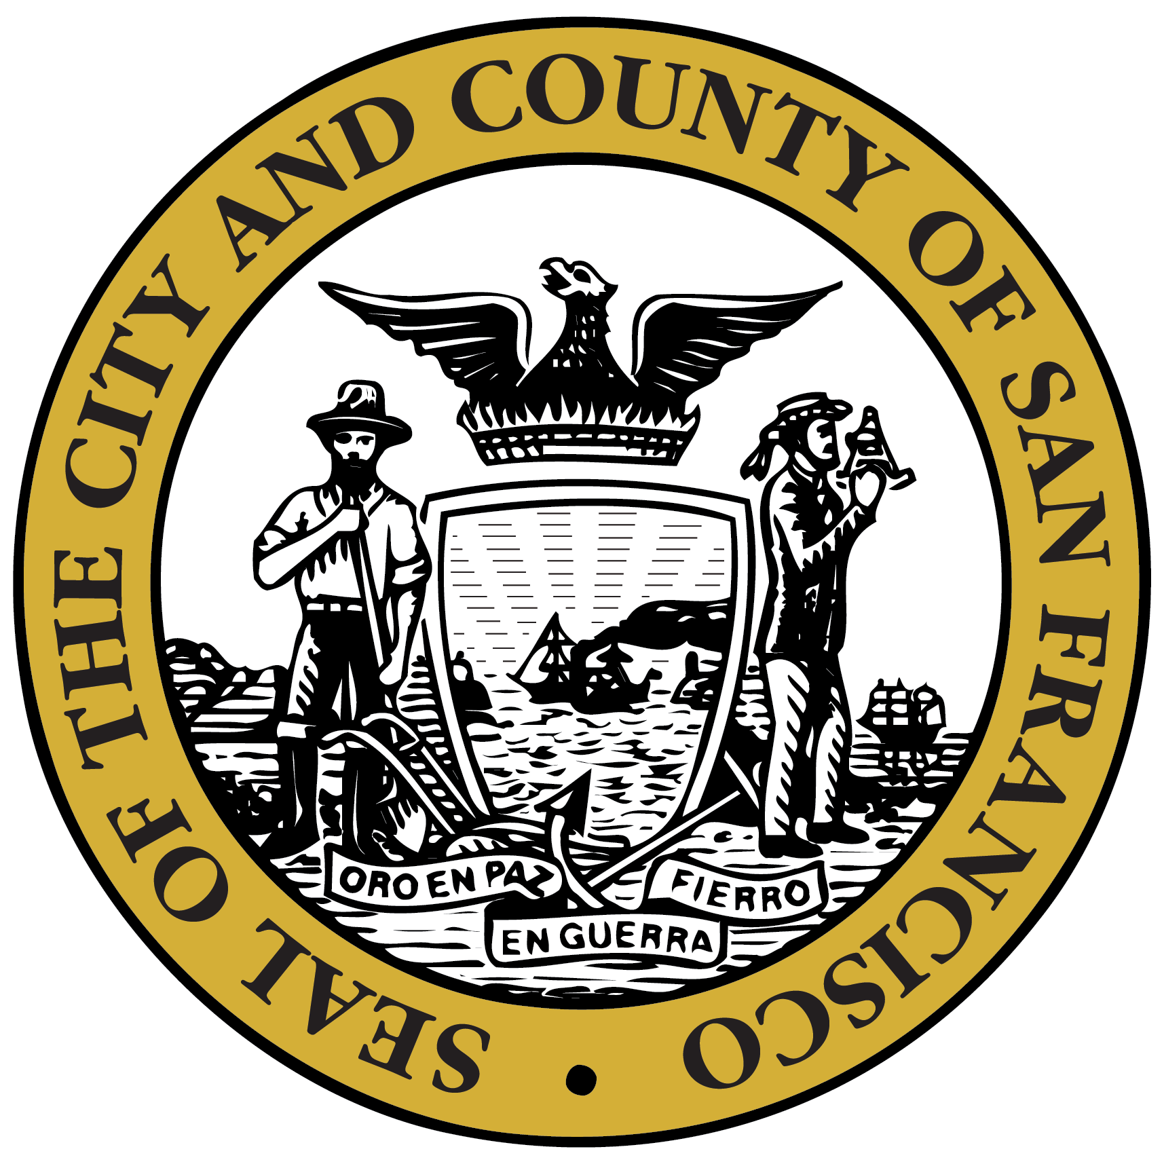
San Francisco Department of Public Health
Grant Colfax, MD
Director of Health

Letters of Support for Grants
Funders may require support letters to accompany grant applications. These letters are in support for DPH grant applications and for those agencies funded by DPH. In all cases, Letters of Support requested for signature by the Director, Grant Colfax, MUST first be emailed to the Office of the Director of Health for review. This allows the Director’s Office to track all requests and to avoid duplicate letters.

Please Note: All Letters of Support MUST go through the Office of the Director of Health. Therefore, the Director of Health is the ONLY authorized signatory to sign on behalf of the Department of Public Health.

Letter of Support Guidelines
- To obtain a Letter of Support from the Director of Health, please prepare to submit (email) the following items to the Director’s Office at least TWO weeks in advance of the requested due date:
- Letter of Support Request Form (See Page 2)
- DRAFT Letter of Support
  - Letters of Support must include the formal address of the addressee.
“To Whom It May Concern” will not be accepted.
  - The Director of Health will NOT sign Letters of Commitment, only support letters.

The Office of the Director of Health receives a large number of requests for signatures that need to go through the appropriate review process. Therefore, "Letters of Support” requests are required to be submitted TWO weeks in advance of the requested due date. We understand that there will be last minute requests for Letters of Support and will do our best to accommodate accordingly. However, failure to provide a two-week notice may result in not receiving a signed Letter of Support.

Letter of Support Process
The following details each step in the Letter of Support process:
- Fill out the Letter of Support Request Form and email to the Director’s Office WITH the draft letter.
  - Note: The Director’s Office is not responsible for drafting the letter. Please do not request that we include additional information in the letter. We request the letter be finalized when it is submitted for approval. The Director’s Office will be responsible for placing the letter on official letterhead.
- Once the draft letter AND request form have been received, the Director’s Office will review the letter and contact you if there are questions and/or issues.
- After the Director’s Office has reviewed, approved, and signed the letter, the Director’s Office will EMAIL an electronic version of the letter to the designated contact person.
  - If you wish to receive the letter with an original signature, please notify the Office of the Director of Health once you receive the electronic copy.

COMMUNITY LETTER OF SUPPORT REQUEST FORM
London N. Breed
Mayor

**MUST BE SUBMITTED AT LEAST TWO WEEKS IN ADVANCE OF REQUESTED DUE DATE**
ALL FIELDS ON THIS FORM MUST BE COMPLETED.
PLEASE ATTACH THIS FORM WITH YOUR DRAFT LETTER OF SUPPORT.
BE SURE TO INCLUDE THE FORMAL ADDRESS OF THE ADDRESSEE IN YOUR LETTER.
EMAIL to Faye.DeGuzman@sfdph.org when completed.

GRANT INFORMATION
1. Type of Grant: |  | Federal |  | State |  | Private |  | Other

2. Name of Grant Funding Agency:

3. Official Title of Grant Application on Announcement:

4. Request for Applications (RFA)/ Request for Proposals (RFP) No.:

5. Catalogue of Federal Domestic Assistance (CFDA) No. (If Applicable):

6. Amount of Grant Funding Applied for: $

7. Date Letter is Requested by: 8. Grant Application Deadline:

AGENCY INFORMATION
8. | Agency Name:
9. | Agency Address:
10. | Telephone No.: | 11. | Executive Director:

OTHER
12. | Letter is Requested by (First Name, Last Name, & Title):
13. | Is Department of Public Health a partner in this grant? Yes No
14. | Has your agency been a contractor with Department of Public Health? Yes No  If YES, when?:  CDTA Contract Officer:
15. | Who is your agency lead for this grant?  Telephone No.: Email:

GRANT DESCRIPTION
A. Project Name
B. Abstract (5-10 Lines)

For further questions, please contact:
Faye DeGuzman | Faye.DeGuzman@sfdph.org

